**MAIN ASSIGNMENT DOCUMENTATION**

**SNOWFLAKE CONSOLE**

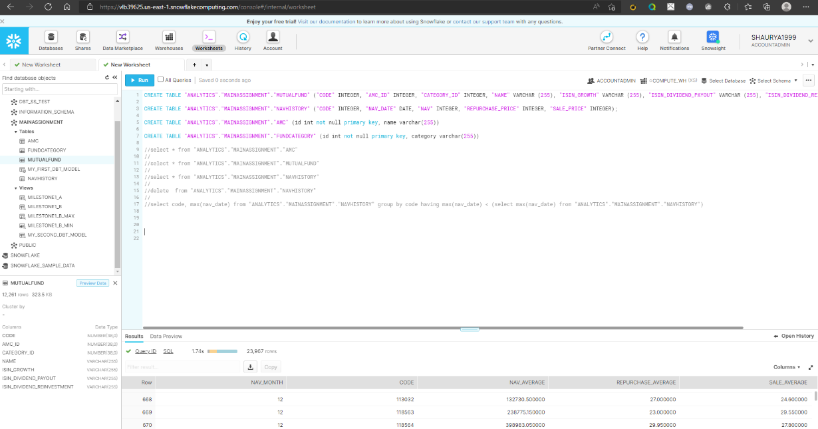

* Created tables for all the files.
* Loaded the data to all the tables using the csv files.

**MILESTONE 1 a**

Calculate Monthly average NAV, Repurchase & Sale Price for each scheme

**Approach-**

Selected the date,code,avg of nav ,avg of repurchase price ,avg of sale price and grouped it by code.

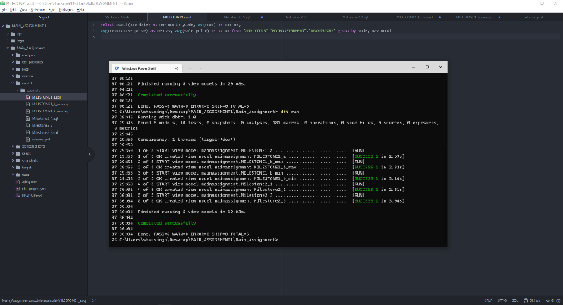

**MILESTONE 1 b**

**Approach –** Made two models one for min and second for max wrote the sql queries respectively.

Searched that on which date the Nav is maximum and then printed the same.

Searched that on which date the nav is minimum and then printed the same**.**

Find out each scheme’s Max and Min NAV value and Date it occurred

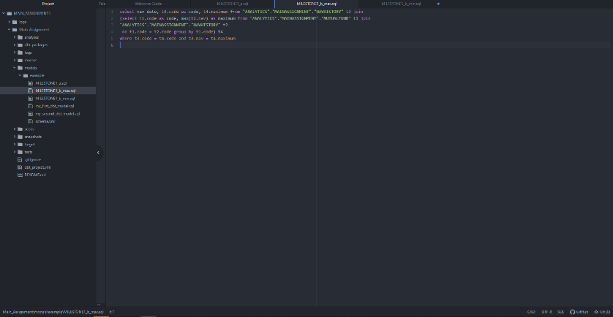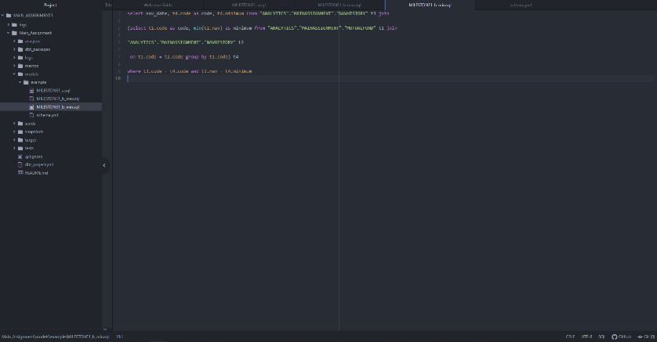

**MILESTONE 2**

3.Medium: List of mutual funds which were discontinued in a given year

Approach – Checked which milestone had not continued from a particular year to the max date ,

Which code was not found till the next year that mutual fund was discontinued.

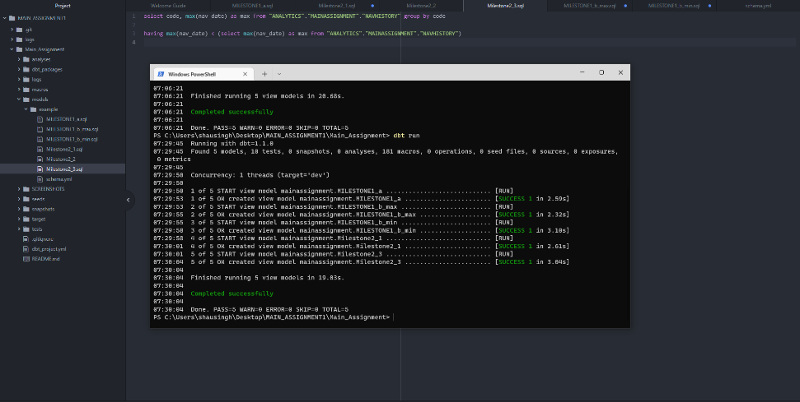

**MILESTONE 3**

**DATA STUDIO LINK - https://datastudio.google.com/reporting/48195805-9a7b-4d11-a365-155633353e4c**

1. Plot performance of upto 3 funds for the past 3 months. [line]

Approach

* Plotted the three different charts for three different mutual funds.
* First- SAHARA BANKING & FINANCIAL SERVICES FUND- GROWTH - Direct
* Second- Sahara Midcap Fund-Dividend Plan
* Third- Essel Multi Cap Fund - Regular Plan - Dividend – Normal

Blended all these tree charts to give a single result .

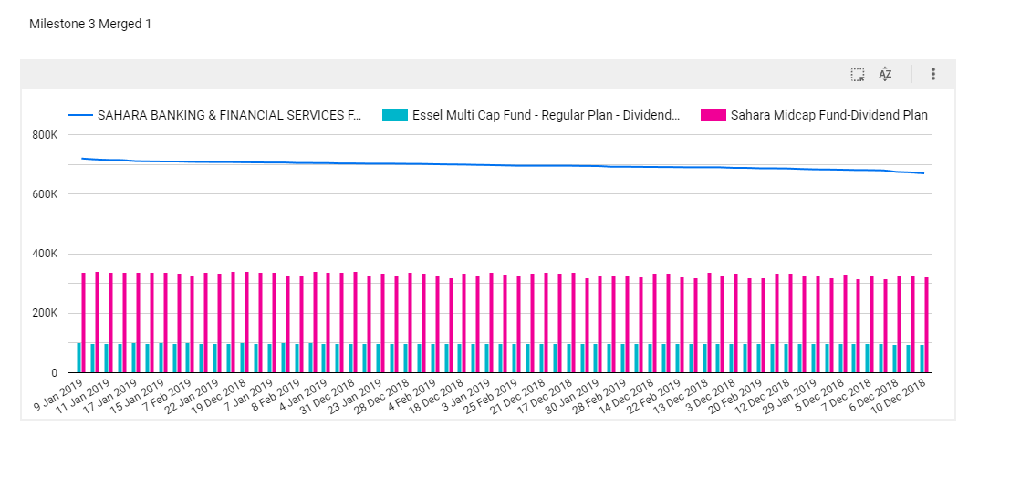

3.Distribution of latest mutual funds based on category. [pie]

* Created a table where the columns were – code,name,category id,category
* Created a pie chart using that table as data , initialized dimension as CATEGORY,
* Metric as RECORD COUNT

